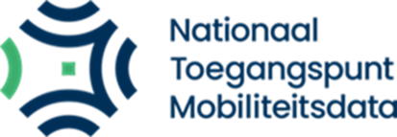 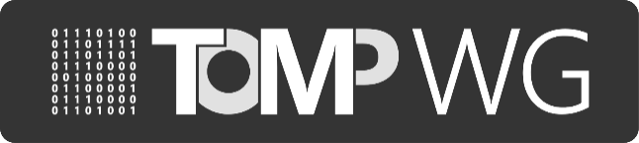

**Report of MaaS-API working group**

*07/06/2023, session #76*

*10:00h-12:00h, Teleconference*

*Attended by (11)*:

Eddy Borremans (Nazza)

Edwin van den Belt (Dat.mobility)

Ayse Öcal (NTM)

Tjalle Groen (Mpact) - Chair

Jelten Baguet (Mpact)

Markus Meijer (SBB)

Jef Hyse (Automicle)

Itzinger Roman (Welsstorm)

Jeffrey van Gils (MaasLab)

Ghislain Delabie (FabMob)

Gerrit Saey (Censys BV)

**Summary of decision points & feedback from actions from previous working session** The following tasks were defined during the previous sessions:

|  |  |  |  |  |
| --- | --- | --- | --- | --- |
| *No.* | *Context* | *Tasks* | *Status* | *Due date* |
| 70.1 | Involve car-sharing operators and discuss  progress on implementing  TOMP-API | Bram will do his best to provide more details about which car-sharing operators are interested in using TOMP-API. Also, an update about which are using a third-party provider for their IT solution or the mobile app.  Action: Tjalle will try to get involved one last time. | To do | No deadline |
| 74.1 | NAPCORE WG seeks collaboration with the TOMP WG.  NAPCORE had a discussion about booking APIs. | NAPCORE finds the TOMP-API overall useful for bookings, but there are cases that the API doesn’t cover (for example tourist tickets). There is potential for a collaboration to cover this GAP.  Update: Anastasia is preparing a document with this information. Eddy and Edwin will receive it when it’s done. | To do | Next Meeting & following |
| 74.1 | Discussion about the alignment with CEN, Transmodel, OSDM. | Action: Impact assessment needs to be done for the TOMP WG when collaborating with CEN, Trans model, OSDM.  Action: 6th of July the result will be shared in the CAB. Input will be gathered and discussed at the next general meeting. | To do | Next Meeting & following |

# Update WT1 Technical issues

Wt1 considered to postpone the version 2.0, because of the CEN, OSDM discussion. Edwin came with a suggestion to release version 1.5 instead of version 2.0 next autumn. There were no objections within the group. The change advisory board will be informed by Edwin and Eddy about the impact of the new version.

* At the ITS Congress MMTIS and MDMS were addressed, there is an opportunity that TOMP will be an European reference standard. Edwin will ask about the requirements to be a reference standard.

# Update WT2 Reference implementation and certification

* Eddy came to the conclusion that they need a professional approach for the market consultation. NTM will hire a professional team to do this consultation.

the members of the working group will be involved later on.

* Eddy will get in touch with the contact person of APDS.

# Update WT3/4 Standards and communication

* Currently the working team is small. Volunteers can contact Tjalle to join WT3/4
* Jelten suggested to post a LinkedIn post about the presentation Edwin did on the ITS Congress. Action: Jelten and Edwin will contact each other.
* Still working on the interviews, blogpost and presentations on different European platforms.
* Collaborate to upload some logos on the website. To show who implemented TOMP.

# Update WT6 Governance

* WT6 temporarily stopped. After the impact analysis is done, the working team can be activated again.

# Other items

# Volunteers for the rotating chair for the general meeting can contact Ayse.

* Jeff will reach out to Ayse to set up an session or presentation about the BEckn protocol.
* There is a need for a brainstorming session where we think about expanding the working groups and participants.

# The next online meeting (working session #77) will be 12 July 2023.